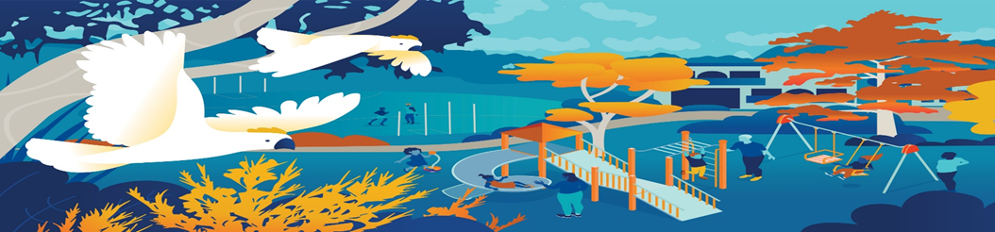

Mount Waverley Water Main Renewal Project
Works Notice- Vegetation Removal

What we are doing

In preparation for the construction of the new water main we will be establishing our work site at Mount Waverly Reserve and will be undertaking vegetation trimming and removal.
An independent arborist has assessed that many of the Cyprus trees around Mount Waverley Reservoir are coming to the end of their life. Due to the risks of branches and limbs falling, the trees will be removed. These works are scheduled to commence on Monday 7 August 2023.
Other trees inside the work zone will be removed as trenching and working beside them can undermine their root systems, making them unstable and unsafe.
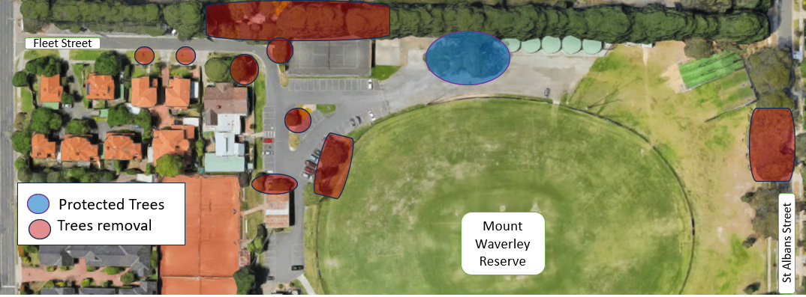
A Tree Management Plan and Tree Protection Plan have been prepared to ensure trees growing within proximity to work zones are not negatively impacted during the project.
Figure 1: Trees marked for removal and protection.

What you can expect
- Tree pruning and removal will be carried out by qualified arborists at multiple locations.
- A qualified wildlife handler will be on site and will arrange for the relocation of any wildlife found during this work.
- Logs and vegetation material from lopped trees will be kept for re-use as part of the reinstatement works. Tree planting will occur after the completion of works.

- Removal of trees in the reserve is outside of the regular council permit process.

